# 

CS-405 Deep Learning Fall 2023

Lab 10

**Improvise a Jazz Solo with an LSTM Network**

|  |  |
| --- | --- |
| NAME | RAJA HAIDER ALI |
| CMS ID | 346900 |
| GROUP | 2 |

Date: 27th Nov 2023

**Report:**

In this lab, we build and train a model to learn musical patterns. The model input X has a shape of (m, Tx,90) and label Y has a shape of (Ty, m,90).

The lab has 3 exercises. In the first exercise, we completed the code for djmodel. We used keras model to create the model instance. Then we made inference using the model and used a comparator function to compare the actual output and the output of the djmodel.

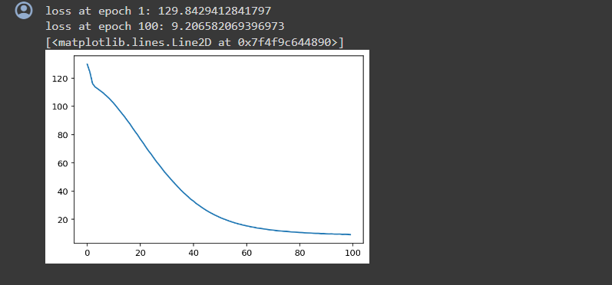

In the second exercise, we completed code for a music_inference_model() to sample a sequence of musical values. We create an empty list and use LSTM cells in the input layer.

In the third exercise, we completed the code for predict_and_sample() in which we used inference model to predict an output given set of inputs. Then convert the pred into a numpy array Tx.

